CSA 283: Exam Two

Name: ______________________________________ Section: _____ _____

Please write legibly. Ask questions if something is unclear. Write down any assumptions you make.

EXAM IS PRINTED ON BOTH SIDES OF THE PAGE.

- In the typical Internet protocol stack, which protocol will provide reliable connection oriented service? (2 points)

_________________

- Give definitions for the following terms using one or two sentences. If the term is includes an acronym, also state what the letters in the acronym stand for. (8 points)

a. IPv6:

b. RTT

c. Gateway Router:

d. Inter-AS Routing Protocol

- A block of data for transmission using the TCP protocol has been broken up for transmission into three separate segments.
- The sequence number of the first segment is 770.
- The first segment contains 40 bytes.
- The second segment contains 500 bytes.
- The third segment contains 90 bytes

Complete the following table by writing the correct sequence number for each segment and the sequence number that would be used by the receiver to indicate in order receipt of each segment (Nothing is lost. All arrive in order.) (6 points)

 | Segment Sequence Number | Acknowledgement Number
First Segment
Second Segment
Third Segment

Now assume the second of the three segments was lost in the previous question:

    - What will be the acknowledgement sent by the receiver when it receives the third segment? (3 points)

    - Under a Go-Back-N protocol, what will the receiver do with this third segment? (3 points)

    - Under Selective-Repeat, what will the receiver do with this third segment? (3 points)

- Host A has calculated the congestion window to be 19,000 bytes. The receive window received from Host B to which the host A is sending data is 12,000 bytes. Host A has transmitted 7,000 bytes of data. 5,000 of these bytes have been acknowledged. What is the maximum number of additional bytes Host A can transmit to Host B at this time? Why is A limiting it transmission rate in this manner? (8 points)

- Describe a situation which will cause a TCP fast retransmit transmit to occur. What is the purpose of fast retransmit?( 4 points)

- Describe a situation which will require a datagram to be broken into two or more fragments.(3 points)

- If some fragments of a datagram are corrupted, what will the IP protocol do with uncorrupted fragments that it does receive? (3 points)

- Break the following datagram (containing 1890 bytes of data) into as many fragments. Assume MTU = 860 bytes. For each fragment, give the length, fragmentation flag value, and the offset that would be carried in the fragment. Assume the IP header is 20 bytes long for all fragments. (8 points)

Original Datagram:
 | Length = 2000 | ID = 22 | Fragflag = 0 | Offset = 0

Fragments:
 | Length = | ID = | Fragflag = | Offset =

 | Length = | ID = | Fragflag = | Offset =

 | Length = | ID = | Fragflag = | Offset =

 | Length = | ID = | Fragflag = | Offset =

- TCP flow control uses the number of duplicate acks and timeouts to determine the transmission rate. Assume following events:

- Transmission of data begins at time 0 (RTT 0) with a congestion window size of 1 MSS (Maximum Segment Size).
- Timeout event occurs between at RTT 3 and RTT 4.
- Three duplicates acks received between RTT 9 and RTT 10.
- Positive acks received during all other RTT intervals

Write the size of the congestion window and the threshold for each RTT period in terms of MSS. The CongWin should be adjusted at the end of each RTT interval based on what happened during the interval. (12 points)

Time | Size of congestion Window (CongWin) in Maximum Segment Sizes (MSS) | Threshold in MSS
0 RTT | 1 | ∞
1 RTT
2 RTT
3 RTT
4 RTT
5 RTT
6 RTT
7 RTT
8 RTT
9 RTT
10 RTT
11 RTT
12 RTT

- Below is a portion of a routing table.

Prefix | Link Interface
11001111 00010011 1001 | 0
11001111 00010011 10011001 | 1
11001011 00010111 00011 | 2
Otherwise | 3

    - Give the Classless InterDomain Routing (CIDR) notation for the subnets identified by the first two rows of the table (for example 200.23.16.0/23). Indicate approximately how many hosts each sub-net could contain.
(8 points)

CIDR notation Approx. Number of Hosts

________________________ __________

________________________ __________

    - Using the destination IP addresses, determine which link interface each of the following packets should be sent to. (6 points)

Destination IP Address | Link Interface
11001111 00010011 10011001 11011101
11001111 00010011 10010011 00011000
11001011 00010101 00011000 10101101

- List the two pieces of information are used to identify a UDP socket. (4 points)

_________________

_________________

- Following from the previous question, how does TCP identify a Socket connection? How does TCP use the information? (8 points)
- Using node F in the figure below as the source, use the link state (LS) algorithm to find the shortest path to all other nodes. Show the members of N, the predecessor of each destination, and the shortest known distance to each destination after the initialization phase of the algorithm and after each loop iteration. (14 points)
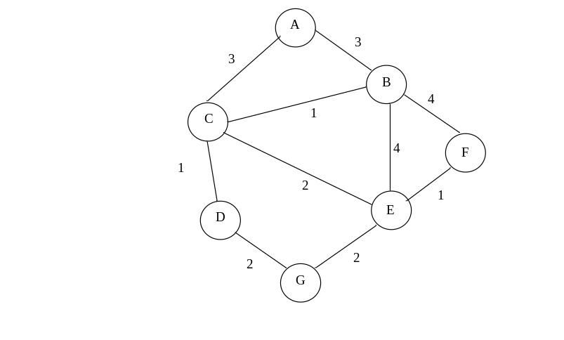

- Use the end results from the previous question to create a minimum spanning tree (MST) for the graph (6 points)

- Figure 1 is a simple network diagram. The network includes three hosts (A, B, and C) and one router. The router is performing Network Address Translation (NAT) using the NAT table below the figure. An application on host C using port 4500 sends a datagram containing an HTTP request to an application running on a host, Z, in the Internet with an IP address of 134.53.29.5 and a port number of 80.
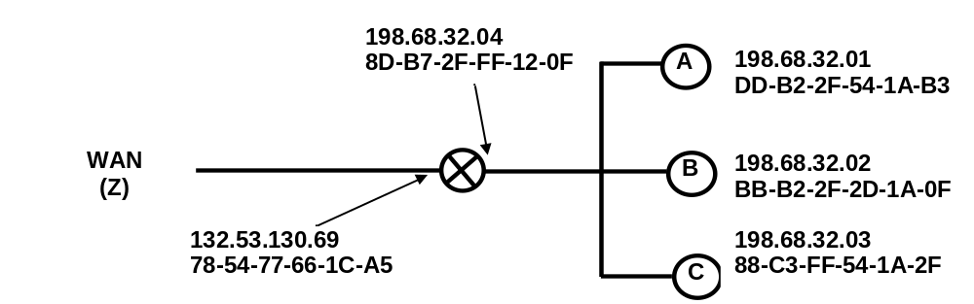
Figure 1: Simple Network with a Router Using the NAT Protocol

NAT Translation Table
WAN side address | LAN side address
132.53.130.69, 4500 | 198.68.32.01, 4500
132.53.130.69, 9005 | 198.68.32.02, 4505
132.53.130.69, 2200 | 198.68.32.03, 4500
… | …

Fill in the source and destination IP addresses and port numbers that will be carried in datagrams at the following four points in the network.
(8 points)

 | Outgoing |  |  | Incoming
 | From B to router | From router to Z | From Z to router |  | From router to B
Source IP
Source Port
Dest. IP
Dest. Port

- How does the TCP protocol detect duplicate packets? Does UDP use this mechanism? (3 points)

- How does the TCP protocol detect lost packets? Does UDP use this mechanism? (3 points)

- How does the TCP protocol detect corrupt packets? Does UDP use this mechanism? (3 points)

- TCP does NOT use network assistance for flow control. (2 points)

TRUE FALSE

- Describe the service provided by a DHCP server using one or two sentences. Describe the sequence of events that occurs when this service is performed. (4 points)

